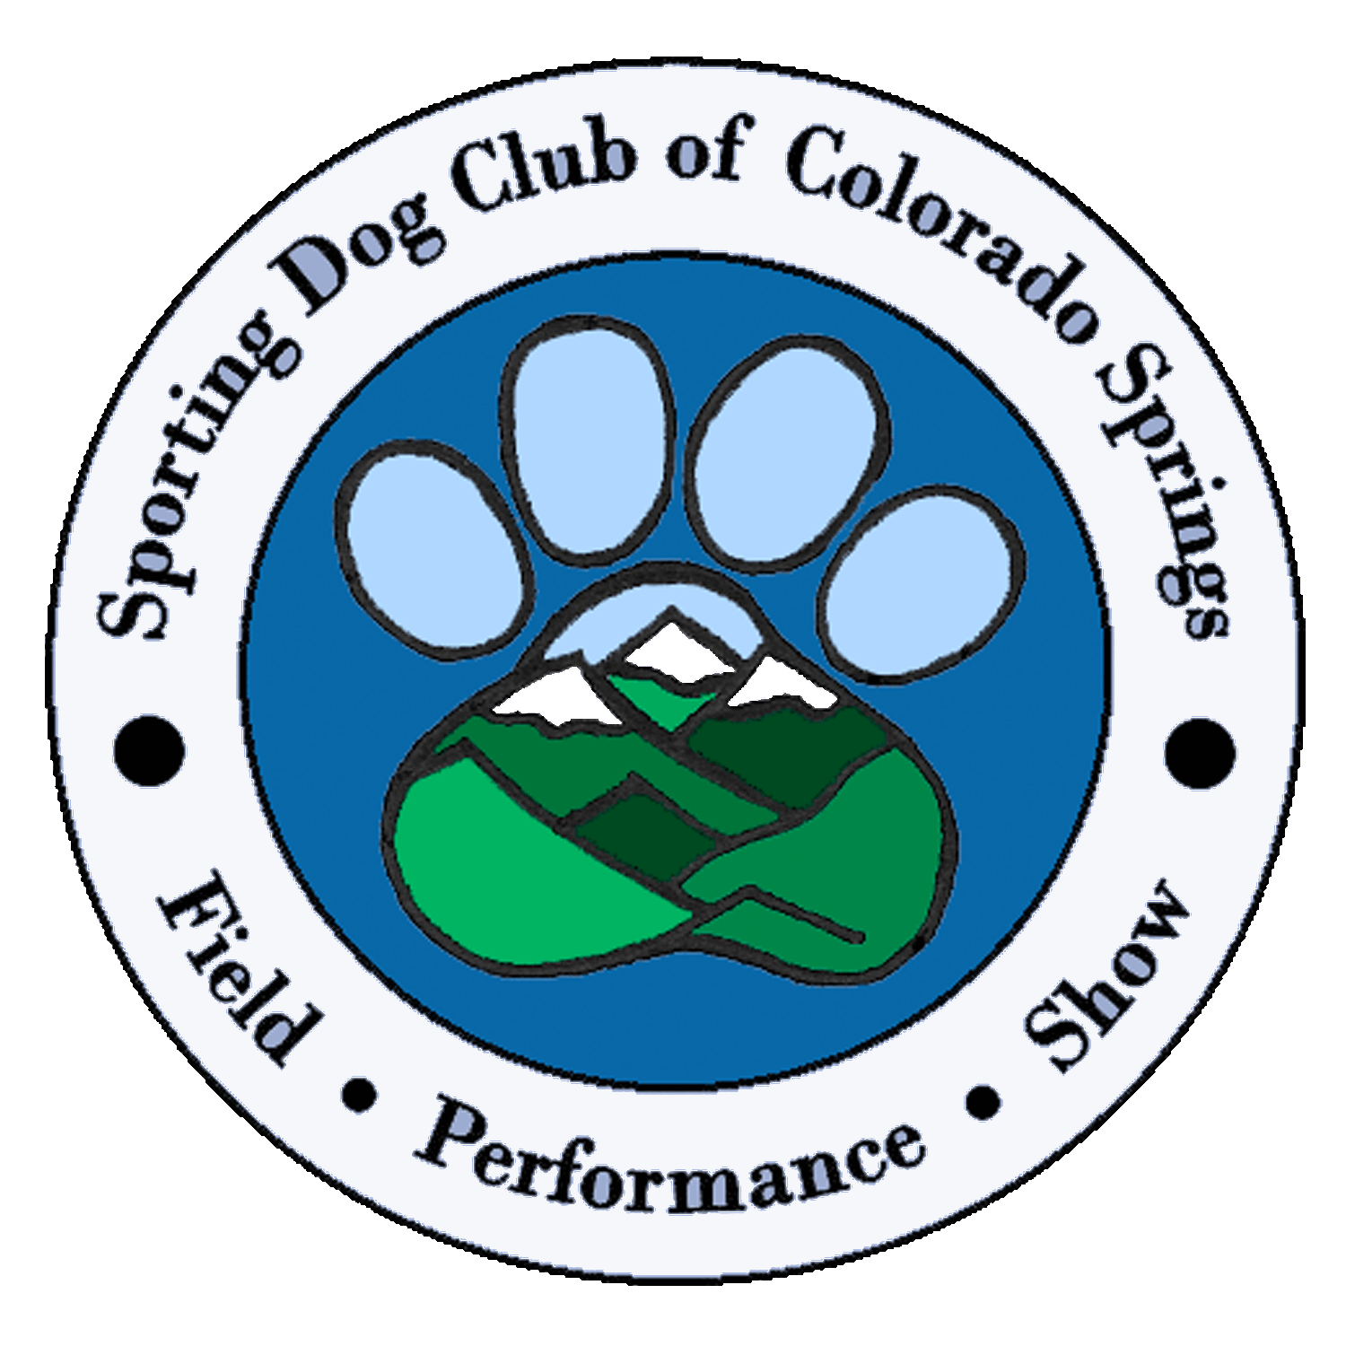
SDCCS May 2021 Newsletter

Happy Month of May Everyone!

With Mother’s Day coming I wish all the Mothers out there and their 2 & 4-legged children a wonderful special day. Our thoughts are with you and thank you for being the Mothers you are. 😇

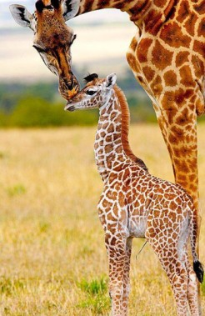
Show Report:
At this time all is looking good for our July 1, 2021 show. Our show premium is in the hands of our Superintendent, Foy Trent. We await the final approval for the premium and then it will be out online .

So many wonderful improvements within the Norris Penrose facility with the air conditioning and the indoor Rest Rooms. We cannot offer R.V. parking because the electrical hook-ups are not in good working order at this time. If you have your own generators and can keep cool in the July heat, then you will be ok.

Still unsure how the judges and workers will be fed, but that will come together shortly as we are told that we must use the food facility at the show site.

We need stewards for Sweep Stakes and Obedience. If you are able to help in those areas, please let me know. Remember stewards are paid and fed.

IN THE WHELPING BOX

Norma Janke;
Black and Yellow Labradors: 303-589-3741

Paul and Joleen Guttenberg
Black Labradors: 719-367-0471

Get your brags and litter information to Sue Harrington, pikespeaklabs@gmail.com

SPOTLIGHT

Marney McCleary - Rocking Thistle Labradors - One of our first SDCCS members

I was born at Glockner Penrose Hospital in September of 1948. My father introduced the first AKC Registered Labrador Retrievers to Colorado Springs, CO. in the late 1940's on the campus of Colorado College. Dad bred and trained sporting dogs for a hobby. He was a true hunter and sportsman and taught me the craft. My father continued to own this wonderful breed until shortly before his death 11 years ago.

Labradors have been an integral part of my entire life. I started showing Labradors in 4-H, and then in AKC conformation and field trials in 1973 under the Rocking Thistle Kennel name. I finished my first chocolate champion in the early 90's- AM. and CAN. CH. Forecast Nordic Thunder, at the Labrador Retriever Club of Albuquerque Specialty, which was a feat in those days!

I was raised and lived in Connecticut. I learned breeding fundamentals under the guidance of my mentor Bette Curtis, the owner of Forecast Kennels, in Litchfield, Connecticut. I have bred two litters in the last three years, as I do not do a lot of breeding. I have bred and owned several specialty winners and Grand Champions (in the US and Canada).

I went off to college at the University of Wyoming. After graduation, I moved to a farm that my father acquired south of Cheyenne, Wyoming, and North of Fort Collins, CO. I bred and raised Champion ADGA Registered Nubian Dairy Goats under the Rocking Thistle name along with my dogs until 1993, when I moved to Summit County and then to Denver for 15 years.

I have spent my professional life as a developer of affordable and workforce housing in northern Colorado and Denver, and I still work in the non-profit sector, remotely, as a Project Developer for Rural Community Assistance Corporation based in Sacramento, CA. I now live in the forested hills between Kalispell, Montana and Whitefish, a stone’s throw from Glacier National Park and Flathead Lake.

I am a founding member of the Labrador Retriever Club of Greater Denver and am currently a member. I served on the LRCGD board for the final time in 2008, when I moved to Montana.

I am a member of the Sporting Dog Club of Colorado Springs and have participated remotely in the club since 2009.

I joined the Flathead Kennel Club of Montana in 2009. I have served as Secretary, President, AKC Liaison, and Board Member, and Show Committee Member/Chief Ring Steward.

There are presently five dogs in my household:
- CH. Rocking Thistle Ain’t My First Rodeo, AM. and CAN.
- Champion Rocking Thistle Zafari Déjà vu, CH
- Rocking Thistle Ruffian by Rogue,
- Rocking Thistle Cinnamon Girl at Everso (co-owned with Stefanie Perrine), and
- Dreamweaver’s Serengeti at Rocking Thistle (co-owned with Ellen Massie).
I also co-own two wonderful Chocolate Labradors with my dear friend Sue Harrington:
- Rocking Thistle Amazing Grace at Pikes Peak; Puppy Star, CGC, ADV. and URBAN CGC, WC
- Willcare’s the Son Also Rises, WC.

Over the years I have been very proud of the fact that Rocking Thistle puppies become wonderful and loyal companions, search, rescue, performance dogs, and champions of record; and at the same time, are healthy, happy, and conform to the Labrador Retriever Standard!

Thank you for asking me to be your featured member of the SDCCS for the May Newsletter!

Marney
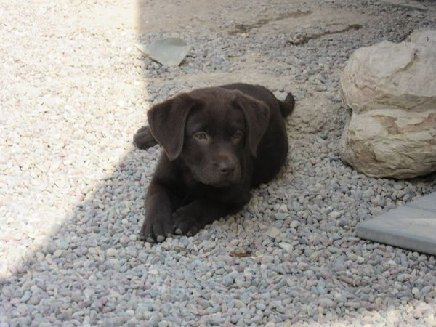

Rocking Thistle Labradors
192 Browns Road Kalispell, MT. 59901.
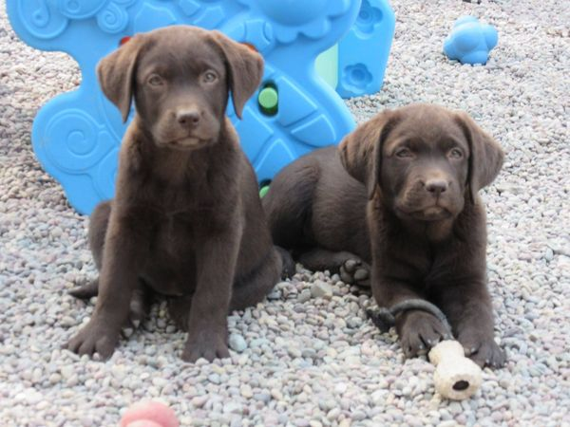
Cell phone - 406-471-2328

